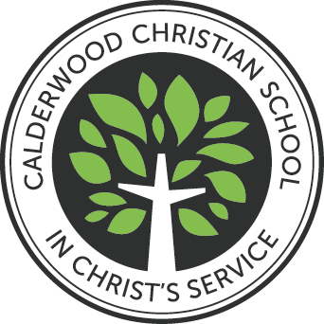

School Uniform Policy

Prepared by | Principal/Heads of School
Date Prepared | November 2025
Monitored by | Principal
Review by | Principal/Heads of School
Date for review | January 2026
Status | Final
Policy Pertains to: | All students

Version History
Version | Date | Notes
1.0 | February 2020 | New Calderwood Christian School policy
1.1 | January 2022 | Changes to wording only – Head of School
1.2 | June 2024 | Addition of text re Athletics Carnival and Non uniform days
1.3 | November 2025 | Language around haircuts and earrings reviewed and enhanced. Length of girl’s skirts, culottes and skirts defined.

Calderwood Christian School Mission: In Christ’s service to partner with parents in providing a quality Christian Education founded on the Word of God.

Table of Contents
1. PURPOSE OF THIS DOCUMENT 4
2. WHY HAVE A UNIFORM 4
3. EXPECTATIONS 5
School shoes 6
Sports shoes 6
Jewellery 6
Makeup 6
4. PROCEDURES 7
Junior School 7
Secondary School 7
Non-Uniform Days 8

PURPOSE OF THIS DOCUMENT
This document explains why we have a school uniform and how it complements teaching and learning. It describes how the uniform is to be worn and outlines the dress code for students at Calderwood Christian School.

WHY HAVE A UNIFORM
- First and foremost, a uniform forms part of the hidden curriculum of a school. Along with the daily routines, Christian practices, and disciplines, wearing a uniform is educational.
- The essence of a school is not the building, the facilities, or the programs, it is the people. Uniforms invite students to invest in something far greater than themselves.
- Uniforms contribute to a strong sense of belonging to a reputable and culturally rich community.
- The practice of wearing a uniform teaches discipline by encouraging detailed attendance to a routine task that can be easily completed to a high level of accuracy and consistency.
- Encourages the child to take pride in their school.
- Prepares students for the many expectations, including presentation, and the high standards of the workplace.
- Minimises opportunities for bullying due to different clothing standards because of personal choice or financial capacity to purchase trending fashion.
- Removes the distraction from the essential purpose of being at school; academic, social, physical, and spiritual development.
- Ensures that students are distinguished by their God-given gifts, their talents, their desire to improve, their progress, their spiritual maturity, their service and so much more, rather than by their clothing, adornments, jewellery, or haircut.
- Contribute to the safety and well-being of students whilst they are not at school. The young person is quickly and easily recognised as a school student and belonging to Calderwood Christian School.
- The good name of Calderwood Christian School proceeds each child when they are in public venues, travelling on public transport or entering workplaces.
For the reasons outlined above, it is the policy of the school that parents provide the approved school uniform and ensure their children wear it every day in accordance with the Dress Code. That is, students are expected to always wear their uniform completely and correctly, including to and from school, on public transport and in public spaces. Students are encouraged to think that “If you have your uniform on, you are representing Calderwood”.

EXPECTATIONS
Parents are to make every effort to provide the approved school uniform and ensure that their children wear it correctly and completely every day. The following guidelines explain how the Calderwood uniform is to be worn and any exceptions that may be permitted.
Formal and Sport Uniforms
- All uniform items are to be neat, clean, not tight fitting and in good repair.
- Tunic and skirt hems are to extend to top of the knee.
- Sport shorts must extend to or below the end of the middle finger of the student standing with their arms by their side.
- Culottes are to extend towards the knee with a gap of no less than four fingers between the bottom of the hem and the top of the knee.
- Formal white boys’ shirts are to be worn tucked in, except for when they are participating in sports and physical activity.
- To maintain a modest and respectful appearance, girls must wear appropriate undergarments beneath their blouses.
- Ties are to be worn by Years 3 – 12 boys during winter (terms 2 & 3). The top button is to be buttoned up.
- Sports uniforms are permitted all day on designated PE and/or Sport days.
- School hats are compulsory all year.
- Girls may wear the Calderwood blouse with culottes and white socks all year. Black, opaque tights may be worn with culottes in Terms 2 & 3.
- Junior School tunics may be worn all year with the Calderwood blouse. It can also be worn with the short or long-sleeve blouse and tights in winter (terms 2 and 3).
- In Junior School the red jumper is to be worn by Junior School students as the first layer against the cold. The black Calderwood jacket is an optional, additional layer against the cold, when the red jumper is insufficient.
- In Secondary, the black Calderwood jacket may be worn by Secondary Students as an additional layer, or as the sole layer against the cold.
- Any additional, non-uniform layers of clothing are to be plain white and must not extend beyond the uniform or shirt sleeve, i.e. extra clothing should not be visible.
- Hairstyles must be conservative and natural in colour. Bold styles are not permitted. This includes hair that has been noticeably coloured. For public health and safety reasons, all students who choose to wear their hair longer than the bottom of the collar must have their hair tied back neatly using compliant school hair accessories. Hair should not restrict a student’s vision. All boys in Secondary School must be clean-shaven.
Extreme hairstyles, including but not limited to, razor lines, tracks, dreadlocks, sideburns, and styles that have a noticeable contrast in length (such as mullets) are not permitted. Hair should be of uniform or near-uniform length, with no small sections styled away from the scalp (e.g., small plaits, rat’s tails, or horse tails). Hair is not to be cut any shorter than #2. The School reserves the right to determine if a haircut is extreme. Students will be provided one week to visit a hairdresser to correct their hairstyle.
- Tattoos are discouraged and must not be visible at any time (including sporting events);
- Parents should make every effort to provide the approved school uniform and ensure that their children wear it every day. Should any family have practical difficulties meeting this requirement they are to contact the appropriate Head of School.

Jewellery
Earrings must be limited to one stud or sleeper in the lobe of each ear. Studs and Sleepers must be plain gold or silver and be a matching set. Studs must be no larger than 3-4 mm in diameter and are not to contain any coloured stones. No other piercings are permitted.
Year 11 and 12 students are permitted to wear clear piercing retainers.
Necklaces and bracelets are not permitted.
Medic Alert necklaces or bracelets are allowed.
Students may also wear a watch and small signet ring.
Religious symbols are not to be on display as jewellery; they may be attached to the inside of the uniform.
Makeup
Fingernail polish and false fingernails are not to be worn. Secondary students from Years 7-9 are not permitted to wear makeup. Years 10-12 girls may wear the following makeup in light, natural tones:
- light foundation
- black, brown or clear mascara
- clear lip gloss
- no contouring, brow colour or eye liner permitted

PROCEDURES
These procedures outline the implementation of the Calderwood Uniform Policy. The uniform policy is applied by Calderwood staff within the context of high expectations and gracious understanding:
- Every teacher maintains the same expectations for every student.
- Every teacher has the authority and responsibility to hold each student accountable for their presentation and grooming.
- Students are always approached graciously, in the first instance, assuming the student has attempted to comply with the expectations.

Junior School
- At the commencement of each school term, students are reminded of the Calderwood uniform expectations. These expectations are also included in the Junior School Parent Handbook for reference throughout the term.
- If a uniform is incorrect or incomplete, the classroom teacher will discuss uniform requirements with the student and speak with the parents. Teachers will maintain records of incomplete or incorrect uniforms in SEQTA to support future conversations.
- Parents of students who attend school on three occasions in incorrect or incomplete uniform will be invited to meet with the Classroom Teacher/Junior School Coordinator to discuss the matter.
- Parents of students who repeatedly attend school in incomplete or incorrect uniforms will be invited to meet with the Head of Junior School to discuss strategies to prevent further breaches.

Secondary School
- At the commencement of each school term, students are reminded of the Calderwood uniform expectations.
- If a uniform is incorrect or incomplete, the student is required to collect an “Incomplete or Incorrect Uniform Slip” during roll call at the start of each morning.
- The student is to carry this slip on them for the day, to prevent being corrected by more than one teacher in the day.
- A record of the “Incomplete or Incorrect Uniform Slip” will be made in SEQTA (Uniform Infringement).
- Parents will receive a notification of this record via SEQTA Engage.
- Students who choose not to collect an “Incomplete or Incorrect Uniform Slip” will receive a detention (during the second break) for choosing not to comply with the school Uniform Policy.
- When a student attends school on three occasions in incorrect or incomplete uniform, the parents will be contacted by the relevant Pastoral Care Teachers.
- When a student chooses to consistently attend school with incomplete or incorrect uniform, parents will be invited to meet with the Character and Service Coordinator and/or Head of School, to discuss actions to prevent further breaches.

Non-Uniform Days
In keeping with the school's values, clothing that is worn on non-uniform days and selected excursions must be modest and appropriate for the occasion. Please note, that the final decisions regarding modesty and appropriateness will be left to the discretion of the supervising teacher and/or the Principal.
In general, clothes must be of modest design and fit (i.e. not see-through, tight-fitting or short). Students are required to wear hats as per the hat policy.
Tops
Shirt should not have any objectionable writing or pictures. Tops and bottoms must meet or overlap. Strapless tops, spaghetti straps, or off the shoulder tops are not permitted.
Bottoms
Shorts and jeans must be worn so that underwear is not visible. Jeans and denim shorts must not have large rips in them. Pants should not be tight-fitting. Leggings can be worn under a skirt, dress or shorts. Skirts/dresses/shorts must be of a modest design and length. The length of shorts must be below the middle finger of the student standing with their arms by their side.
Shoes
Fully enclosed shoes must be worn. If there is any occasion where other styles of shoes are allowed, this will be noted on the excursion note.
Swimming costumes
All students must wear a rash shirt with their swimming costume unless they are competing in a swimming race. Board shorts may be worn over costumes. When representing CCS in any school event, girls are required to wear a modest one-piece costume. Boys can wear swimming costumes of modest design.
Sports Carnivals and Representative Sport
Students are permitted to wear appropriate and relevant sportswear to compete in races. However, when students are not competing, they are to wear tops that cover the shoulders and midriff. They are also to wear modest sports shorts over the top of any leggings/skins/tights whenever they are not competing.
Teachers reserve the right to apply consequences to students who fail to comply with uniform guidelines during the school day i.e. failing to keep their shirt tucked in, or keeping their hair tied up.

School shoes
At Calderwood, we are concerned about the safety of our students. Many of the shoes available for sale, do not provide adequate foot protection and are not appropriate for certain subjects such as science and technical classes. Your child is wearing their school shoes almost every school day, so it is worthwhile investing in a quality pair that meets the requirements of our learning environments and ensures your child’s safety.
The school shoe must be sturdy, waterproof and offer full coverage of the foot.
Shoes with Velcro straps are permitted for Kindergarten – Year 2 only.

Below are examples of CORRECT school shoes.
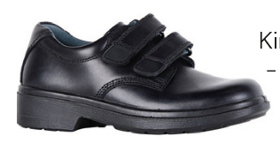
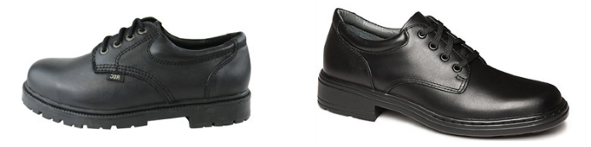

The following shoes are NOT appropriate for school.
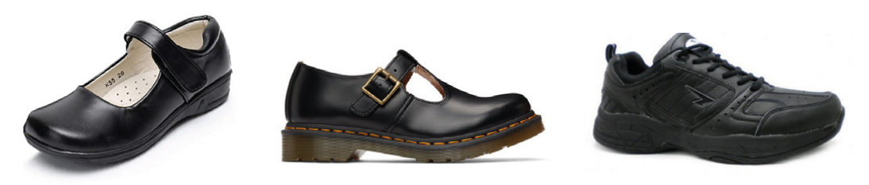

Sports shoes
Sports shoes must be a runner or cross-trainer, specifically designed for physical activity. They may be of any colour and can have up to 50 percent fluorescent colouring.
Casual, flat soled, or skater shoes are NOT acceptable.
Footwear must be in good repair and fastened securely on the foot.

End of Policy

